Wine List
White
Harewood Sauvignon Blanc Semillon (Great Southern) 7.5 33
Trevelen Farm 'Katie's Kiss' Sweet Riesling (Great Southern) 7.5 35
West Cape Howe Pinot Grigio (Great Southern) 8.0 36
The Lake House Semillon Sauvignon Blanc (Great Southern) 45
Rockcliffe ‘Third Reef’ Sauvignon Blanc (Great Southern) 8.5 34
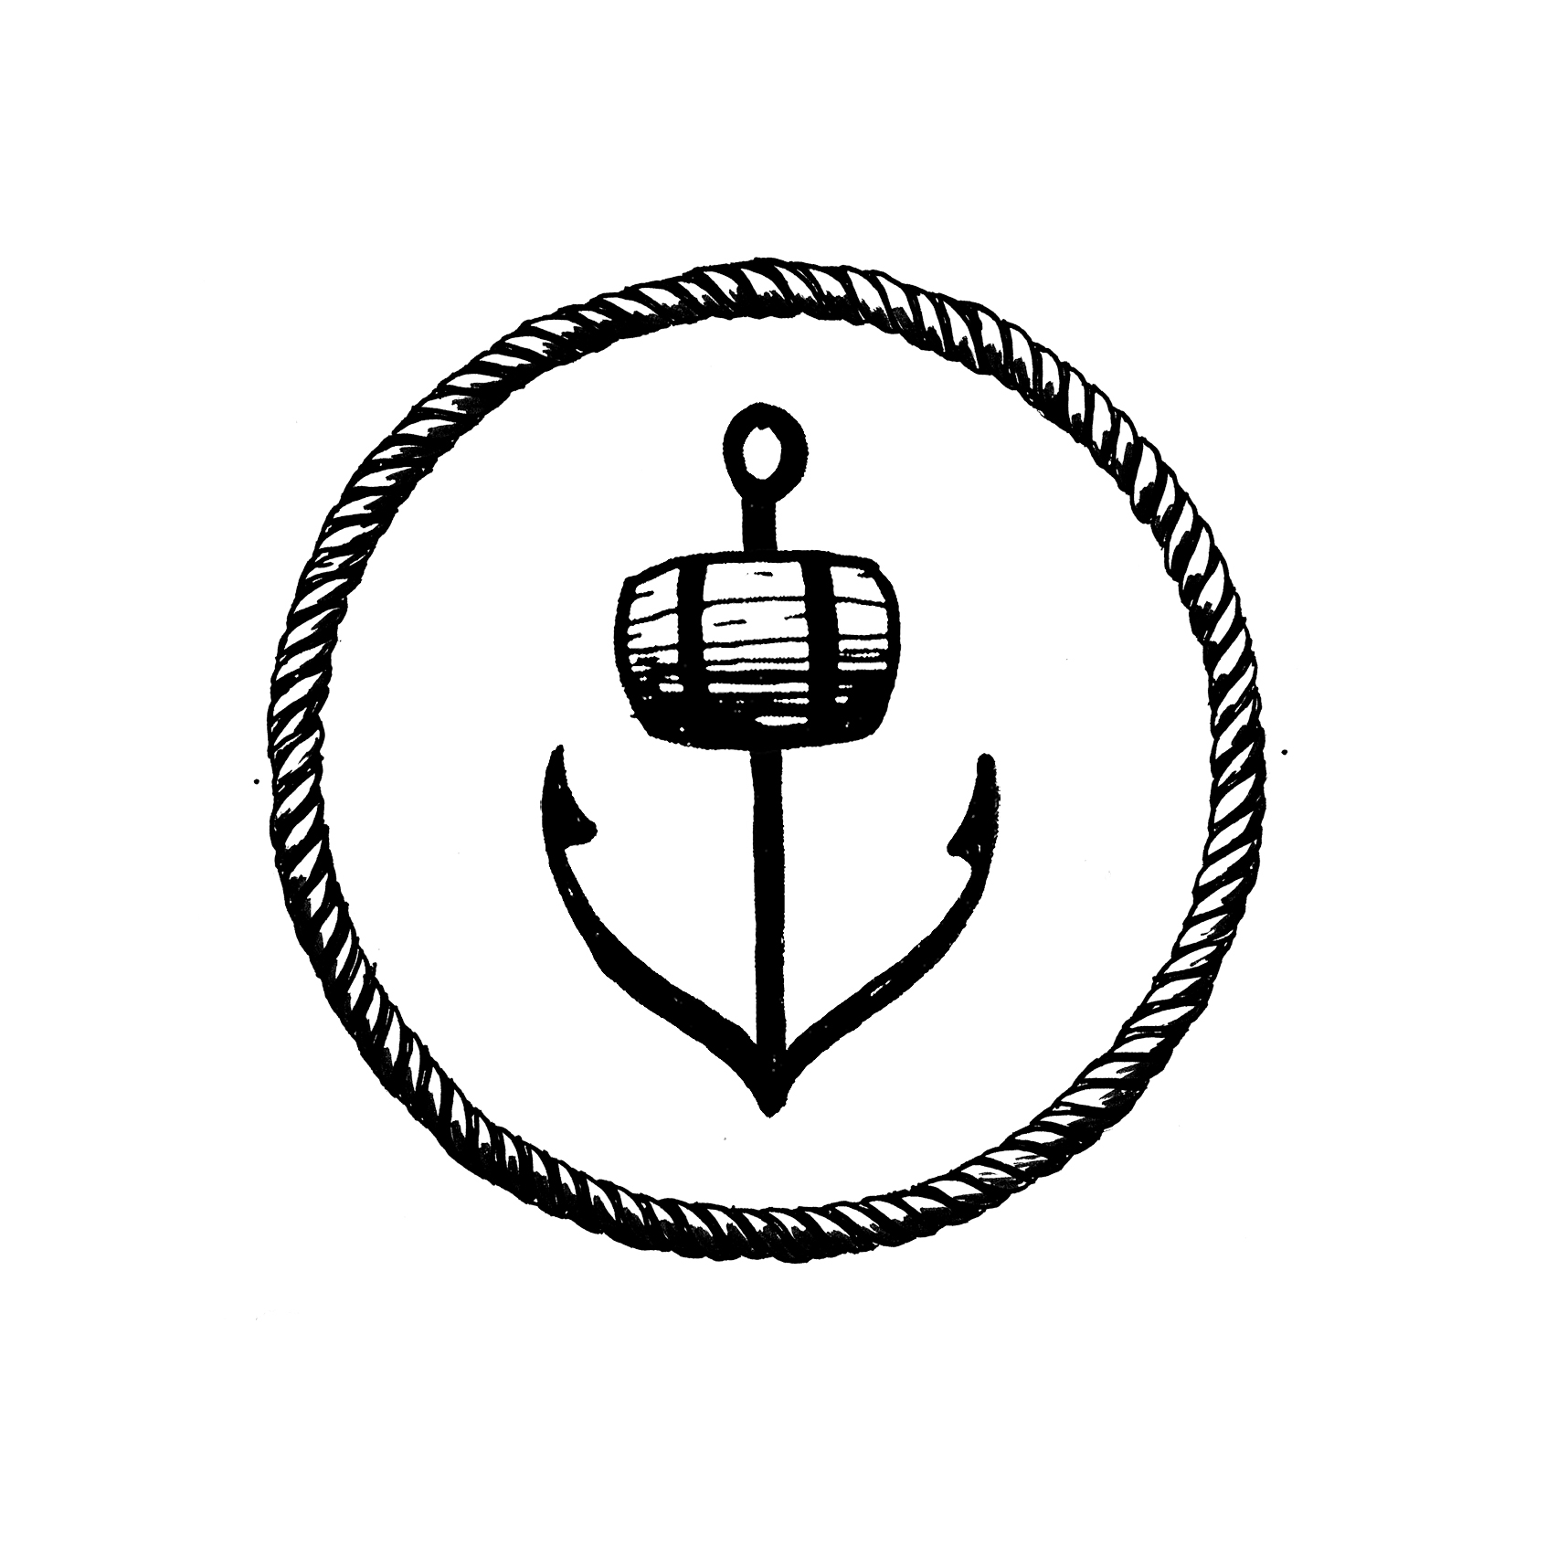
Wignalls Sauvignon Blanc (Great Southern) 38
West Cape Howe Riesling (Great Southern) 8.5 38
Brave New Wine Dreamland Botanical Riesling (Denmark) 60
The Lake House Reserve Riesling (Great Southern) 55
Shepherd’s Hut Chardonnay (Denmark) 9.0 42
Merum Estate Reserve Chardonnay (Pemberton) 65

Sparkling
Somerset Hill Sparkling (Denmark) 9.5 50
Brown Brothers Prosecco Piccolo (King Valley, Victoria) 12
Henkell Dry Sparkling White Piccolo (Germany) 11
Brown Brothers Moscato (Sweet) Piccolo (King Valley, Victoria) 12
Brown Brothers Prosecco Rosé (King Valley, Victoria) 36
Brown Brothers Prosecco (King Valley, Victoria) 36
Devil’s Corner Chardonnay Pinot Noir (Tasmania) 36
Chandon Brut Sparkling (Victoria) 55
The Lake House Reserve Sparkling (Denmark) 65
Rockcliffe 'Rivage' Sparkling Shiraz (Great Southern) 45

Wine List
Red
Harewood Shiraz (Great Southern) 7.5 33
Black Chook Shiraz (McLaren Vale) 8.5 38
Freehand Organic Shiraz (Denmark) 42
West Cape Howe 'Two Steps' Shiraz (Great Southern) 47
La Violetta UP! Shiraz (Denmark) 55
Merum Estate Reserve Shiraz (Pemberton) 59
Rockcliffe “Quarram Rocks’ Shiraz Cabernet (Great Southern) 34
Snake & Herring 'Dirty Boots' Cabernet Sauvignon (Margaret River) 9.0 44
Duke's Vineyard Cabernet Sauvignon (Porongurup) 48
Wignalls Cabernet Merlot (Great Southern) 8.0 36
The Lake House Merlot (Great Southern) 44
Montefalco Organic Sangiovese (Porongurup) 55
West Cape Howe Tempranillo (Great Southern) 42
Rosenthal 'The Marker' Pinot Noir (Great Southern) 9.5 45
The Lake House Reserve Pinot Noir (Great Southern) 65
Rockcliffe 'Quarram Rocks' Rose (Great Southern) 7.5 35

After Dinner 60mls
West Cape Howe Muscat (Mount Barker) 10
Wignalls Tawny Port (Western Australia) 8.5
Wignalls White Port (Great Southern) 10
Freehand Cane Cut Semillon (Denmark) 11

